User Acceptance Testing (UAT) Template
Date | 28 September 2026
Team ID | 6ab221d587602313e82c60c9
Project Name | Import Data using Transform Maps (Spreadsheet)
Maximum Marks | [Maximum Marks]
Project Overview:
Project Name: Import Data using Transform Maps (Spreadsheet)
Project Description: This project imports structured employee data from an external spreadsheet into the ServiceNow platform using Data Sources, Import Sets and Transform Maps, so bulk data can be loaded, mapped, cleaned and verified without manual entry.
Project Version: 1.0
Testing Period: 25 October 2026 to 28 October 2026
Testing Scope:
Features and functionalities to be tested: Data Source creation, spreadsheet loading into the Import Set table, Transform Map creation and field mapping, Coalesce, field transform scripts, handling of invalid rows, Transform History review.
User stories / requirements to be tested: USN1 to USN11 (Sprint 1 and Sprint 2).
Testing Environment:
URL/Location: ServiceNow Personal Developer Instance (https://<instance-name>.service-now.com)
Credentials (if required): [Username/Password]
Test Cases:
Test Case ID | Test Scenario | Test Steps | Expected Result | Actual Result | Pass/Fail
TC-001 | Create Data Source for the employee spreadsheet | 1. Open System Import Sets > Administration > Data Sources  2. Click New, choose type File and format Excel  3. Enter name and save | Data Source is created and saved successfully | Data Source created and saved successfully | Pass
TC-002 | Load spreadsheet data into Import Set table | 1. Attach the employee .xlsx file to the Data Source  2. Click Load All Records  3. Open the Import Set table | All rows from the spreadsheet appear in the staging table | All rows appeared in the staging table | Pass
TC-003 | Create Transform Map and map fields | 1. Open Transform Maps and click New  2. Select source Import Set table and target table  3. Use Auto Map Matching Fields, then map remaining fields manually | Transform Map is saved with all source fields mapped to target fields | Transform Map saved with all fields mapped | Pass
TC-004 | Run transform with valid data | 1. Open the Transform Map  2. Click Transform  3. Open the target table | Valid records are inserted into the target table | Valid records inserted into the target table | Pass
TC-005 | Coalesce on unique field (duplicate check) | 1. Run the transform again with the same spreadsheet  2. Check the target table record count | Existing records are updated; no duplicate records are created | Records updated; no duplicates created | Pass
TC-006 | Field transform script formats data | 1. Add a field transform script to format the name/email value  2. Run the transform  3. Check the formatted field in the target table | Values are stored in the correct format | Values stored in the correct format | Pass
TC-007 | Negative test: empty or invalid rows | 1. Add rows with empty mandatory fields to the spreadsheet  2. Reload the data and run the transform | Invalid rows are skipped and not inserted into the target table | Invalid rows skipped; valid rows imported | Pass
TC-008 | Review Transform History and error log | 1. Open System Import Sets > Transform History  2. Open the latest run and check the counts | Inserted, updated and skipped counts are shown correctly | Inserted, updated and skipped counts shown correctly | Pass
Bug Tracking:
Bug ID | Bug Description | Steps to reproduce | Severity | Status | Additional feedback or comments
BG-001 | Date of joining imported in the wrong format | 1. Load spreadsheet with dates as DD-MM-YYYY  2. Run the transform  3. Check the date field in the target table | Medium | Closed | Fixed by adding a field transform script to convert the date format
BG-002 | Duplicate records created on second import | 1. Run the transform twice  2. Check the target table | High | Closed | Fixed by setting Coalesce on the unique Employee ID field

Test Case Screenshots:
TC-001 - Create Data Source for the employee spreadsheet (Load Data / Import Set table setup)
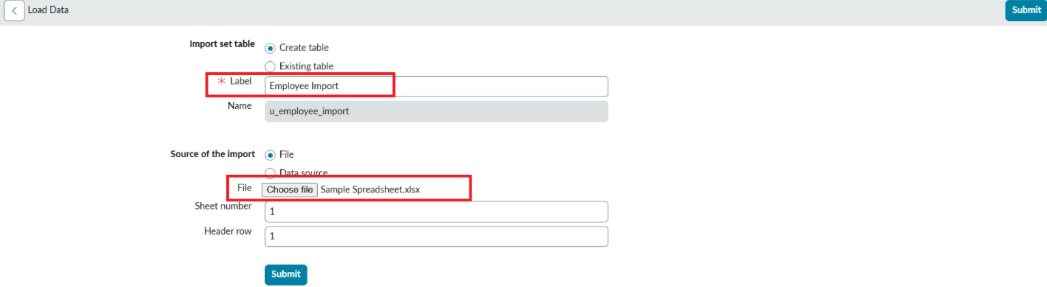
TC-002 - Load spreadsheet data into Import Set table

TC-003 - Create Transform Map and map fields
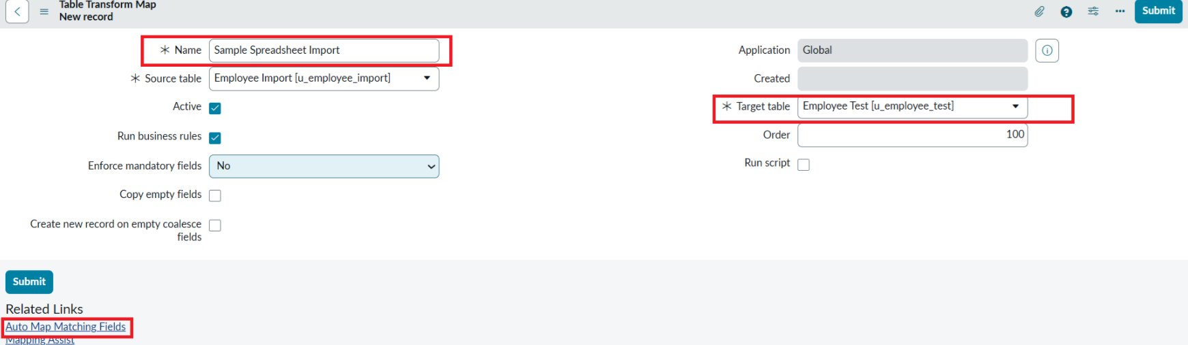

TC-004 - Run transform with valid data

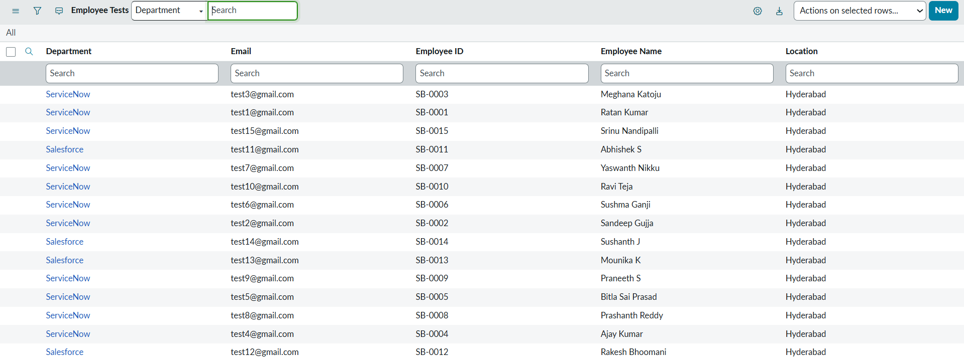
TC-005 - Coalesce on unique field (duplicate check)


TC-008 - Review Transform History and error log

Bug Tracking:
Bug ID | Bug Description | Steps to reproduce | Severity | Status | Additional feedback or comments
BG-001 | Date of joining imported in the wrong format | 1. Load spreadsheet with dates as DD-MM-YYYY  2. Run the transform  3. Check the date field in the target table | Medium | Closed | Fixed by adding a field transform script to convert the date format
BG-002 | Duplicate records created on second import | 1. Run the transform twice  2. Check the target table | High | Closed | Fixed by setting Coalesce on the unique Employee ID field
Sign-off:
Tester Name: [Name of Tester]
Date: [Date of Test Completion]
Signature: [Tester’s Signature]
Notes:
- Ensure that all test cases cover both positive and negative scenarios.
- Encourage testers to provide detailed feedback, including any suggestions for improvement.
- Bug tracking should include details such as severity, status, and steps to reproduce.
- Obtain sign-off from both the project manager and product owner before proceeding with deployment.

